To use Jenkins cli utility, we need to download the Jenkins-cli.jar file

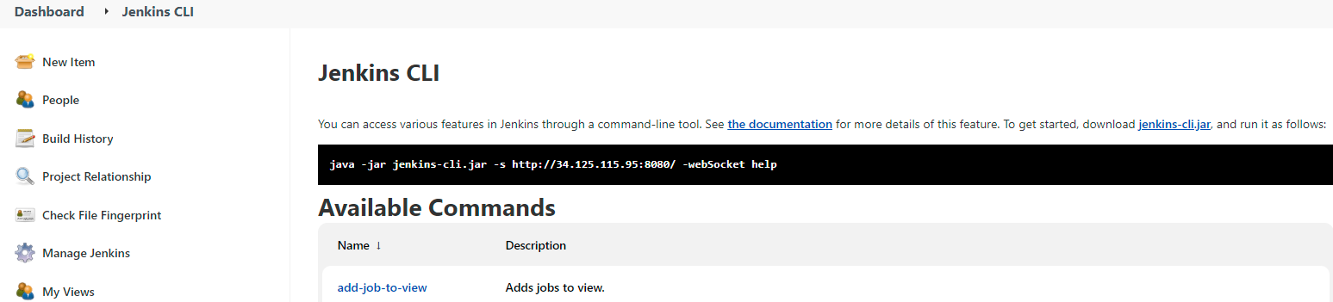

Download Link for Jenkins-cli.jar

To get help on Jenkins-cli utility first run the command using Jenkins-cli.jar,

$ java -jar jenkins-cli.jar –auth admin:password -s http://34.125.115.95:8080/ -webSocket help

1. Get-job… to export job configuration to an xml format

$ java -jar jenkins-cli.jar -auth admin:password -s http://34.125.115.95:8080/ -webSocket get-job build190422 > build190422.xml

1. Create-job … to create a job from an existing xml file input.

$ java -jar jenkins-cli.jar -auth admin:password -s http://34.125.115.95:8080/ -webSocket create-job newjob < build190422.xml